**India Agriculture Crop Production Analysis (1997-2021)**

**1)INTRODUCTION**

**1.1 OVERVIEW**

**Meaning of agriculture production?**

**Cultivating soil, planting, raising and harvesting crops, rearing, feeding, and managing animals.**

**LINK:**

**1.https://github.com/Gowri004/India-s-Agricultural-crop-production-Analysis-NM2023TMID03084/settings**

**2.https://Public.tableau.com/app/profile/gayathri.m3531/vizzes**

**CONTENT:**

**Agriculture accounts for nearly 14 percent of its Gross Domestic Product.**

**Cultivating the soil, growing crops, and raising livestock.**

**1.2 PURPOSE**

**Providing the livestock industry with feed, and the population with food.**

**Agriculture is the foundation of the Indian economy.**

**To collect, interpret, and present data for a wide range of applications and industries.**

**2) PROBLEM DEFINITION & DESIGN THINKING**

**2.1 EMPATHY MAP**

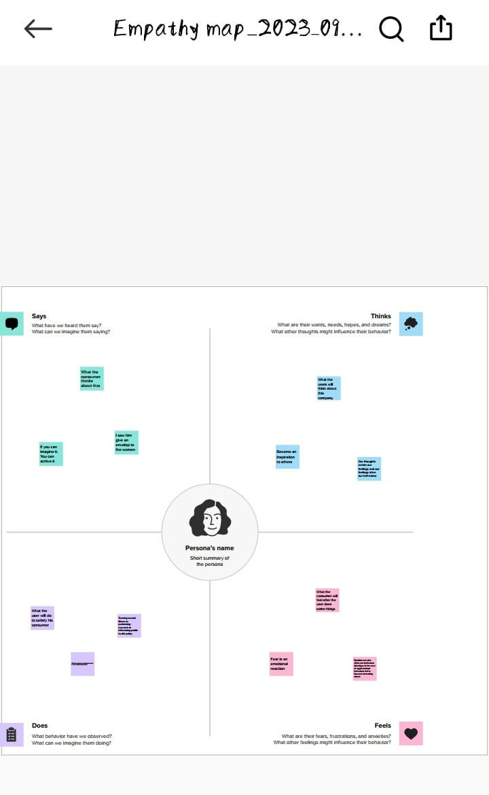**2.2 BRAINSTORMING MAP**

**3) RESULT**

**DASHBOARD 1**

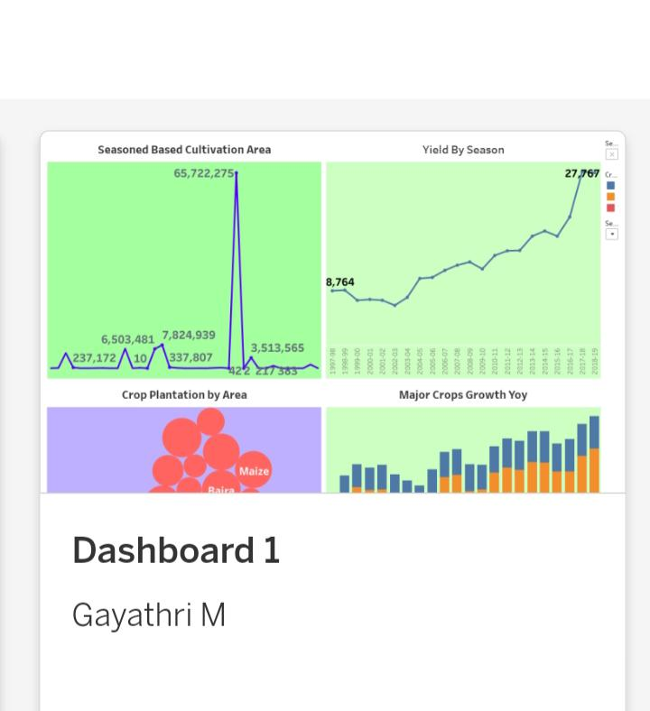

**DASHBOARD 2**

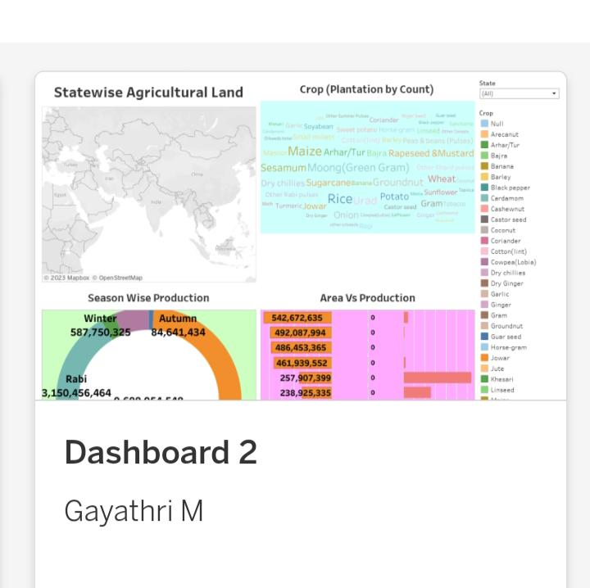

**STORY**

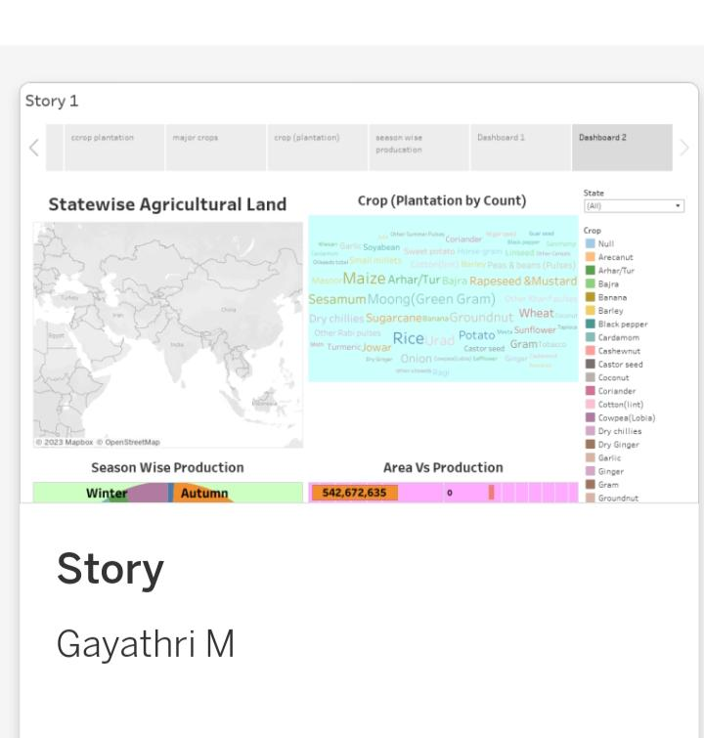

**4)ADVANTAGE & DISADVANTAGE**

**ADVANTAGE**

**ECONOMIC STABILITY : Provides employment opportunity to the rural agricultural as well as non-agricultural labourers.**

**DISADVANTAGE**

**INEQUALITY : Erosion of soil by heavy rain, floods, insufficient vegetation cover etc., reduces farm productivity.**

**5) APPLICATION**

**Fiber-rich crops like bamboo can be turned into a pulp, which can then be used to make paper.**

**Nanoformulations of agrochemicals for applying pesticides and fertilizers for crop improvement.**

**Drug delivery, wound healing, electronics, water treatment, paints.**

**Reduce seed rate, ensure optimum field stand and improved crop performance by managing the seed and soil borne pathogens.**

**6) CONCLUSION**

**Agriculture has given so much to society. But it has own pros and cons that we can’t overlook. Furthermore, the government is doing his every bit to help in the growth and development of agriculture; still, it needs to do something for the negative impacts of agriculture.**

**7)FUTURE SCOPE**

**There will be pressure on agriculture to meet future targets, so innovation will be important.**

**In indian more than 60% indian are primarily dependent on Agriculture and agriculture contributes near 17-18% indian GDP. Pursuing BSC Agriculture can lead to a career in various agricultural industries such as farming, agribusiness, food processing, agricultural machinery, seed production, fertilizers, pesticides and more.**